|  |
| --- |
|  |
| Assignment 2 |
| Network Security (UCS727) |

|  |
| --- |
|  |

*Name:*  Sachleen Singh Chani

*Roll No.:* 101506143

*Date:* April 2021

## Q1. Write a program to implement a simple substitution cipher (Monoalphabetic cipher). Take the plain text as input from the user.

### Answer:

**Code –**

# dictionary to store the letters

LETTERS **=** "ABCDEFGHIJKLMNOPQRSTUVWXYZ "

# their substitution mapping

key **=** "QWERTYUIOP ZXCVBNMASDFGHJKL"

**def** getPlain**():**

**print(**"\nEnter the plain text:"**)**

**return** **input()**

# encrypt function

**def** encText**(**text**):**

cipher **=** ""

# looping though plain text

**for** char **in** text**:**

# changing the lower case to upper case

# keeping encrypted text in upper and plain/decrypted text in lower

char **=** char**.**upper**()**

# finding the character in the key string which maps to the plain text

cipher **+=** key**[**LETTERS**.**find**(**char**)]**

**return** cipher

**def** decText**(**cipher**):**

dcipher **=** ""

# looping through the cipher text single char at a time

**for** char **in** cipher**:**

# finding the character in the Letters string which maps to the key string

dcipher **+=** LETTERS**[**key**.**find**(**char**)]**

# changing the deciphered text back to lower case

**return** dcipher**.**lower**()**

# user input plain text

plain **=** getPlain**()**

# calling the encryption function

cipher **=** encText**(**plain**)**

**print(**"\nCipher text is:"**)**

**print(**cipher**)**

# calling the decryption function

dcipher **=** decText**(**cipher**)**

**print(**"\nThe original plain text is:"**)**

**print(**dcipher**)**

**Result –**

The substitution mapping is done by using a key string which contains all the letters but in a random order. A space character has also been added to the string to encipher and decipher space character as well.

The screenshot in fig. 1 shows the result of the above code. The code goes through the plain text string character by character and simply substitute it with the corresponding position of the character in the ‘Letters’ string to the ‘key’ string

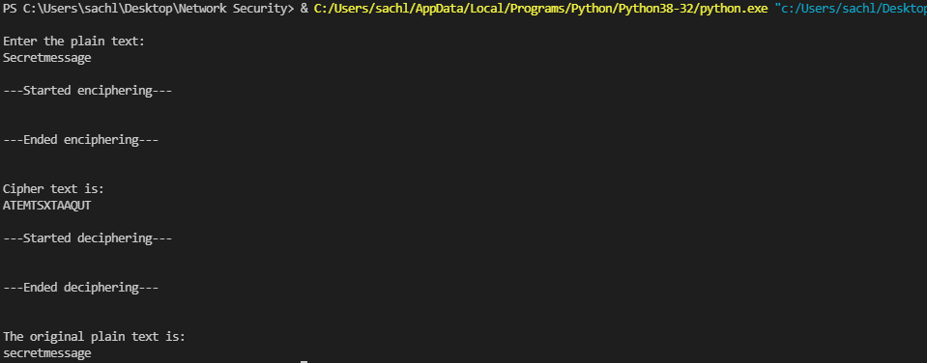

Figure User input plain text

## Q2. Write a program to implement the substitution cipher by reading the plain text from a file.

### Answer:

**Code –**

# dictionary to store the letters

LETTERS **=** "ABCDEFGHIJKLMNOPQRSTUVWXYZ "

# their substitution mapping

key **=** "QWERTYUIOP ZXCVBNMASDFGHJKL"

# encrypt function

**def** encText**(**text**):**

cipher **=** ""

# looping though plain text

**for** char **in** text**:**

# changing the lower case to upper case

# keeping encrypted text in upper and plain/decrypted text in lower

char **=** char**.**upper**()**

# finding the character in the key string which maps to the plain text

cipher **+=** key**[**LETTERS**.**find**(**char**)]**

**return** cipher

**def** decText**(**cipher**):**

dcipher **=** ""

# looping through the cipher text single char at a time

**for** char **in** cipher**:**

# finding the character in the Letters string which maps to the key string

dcipher **+=** LETTERS**[**key**.**find**(**char**)]**

# changing the deciphered text back to lower case

**return** dcipher**.**lower**()**

# open a file in read mode with the plain text

**while** **True:**

# repeat until the try statement succeeds

**try:**

file **=** **open(**"C:\\Users\\sachl\\Desktop\\plaintext_assignment2.ssc"**,** "r"**)**

**print(**"\nFile open successfully!"**)**

**break**

# exit the loop

**except** **IOError:**

**input(**"Could not open file!"**)**

# restart the loop

**print(**"\nPlain text read from file:"**)**

# reading the whole file

plain **=** file**.**read**()**

**print(**plain**)**

# calling encryption function

cipher **=** encText**(**plain**)**

**print(**"\nCipher text is:"**)**

**print(**cipher**)**

# calling the decryption function

dcipher **=** decText**(**cipher**)**

**print(**"\nThe original plain text is:"**)**

**print(**dcipher**,**"\n"**)**

# closing the file

file**.**close**()**

**Result –**

The plain text is read from the file using the read() function.

The text file ‘plaintext_assignment2_q2.ssc’ contains a single line text, ‘Monoalphabetic Cipher’. A check is performed to make sure the file is opened successfully.

The result of the above code could be seen in the screenshot in fig. 2.

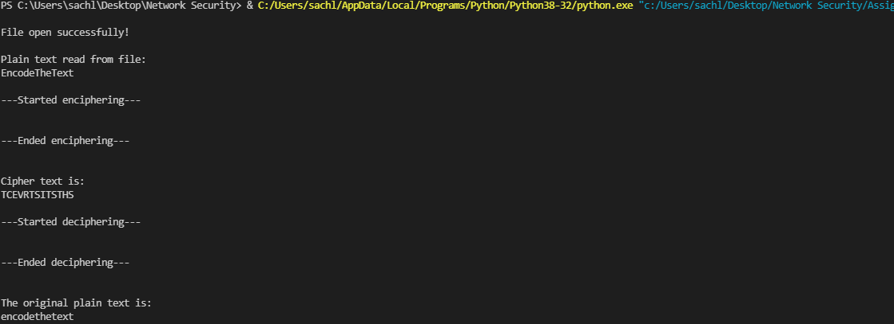

Figure Plain text read from a file